EXPERIMENT 1: HTML/ HTML5 TAGS

Alphonz George

T11-03

AIM: To develop a webpage using HTML5

THEORY:

Here are five key **HTML elements** used in this webpage, along with their descriptions:

**1. <header>**

* **Description**: The <header> element defines the top section of the webpage and typically contains introductory content or navigation links.
* **Purpose**: In this case, it contains the title of the page ("Paradise of Pages") and a navigation bar (<nav>), which includes links to different sections of the page.

**2. <nav>**

* **Description**: The <nav> element is used to define a set of navigation links. It helps users to easily move between different sections of the webpage.
* **Purpose**: Here, it houses links like "New Releases," "Award-Winning Series," "Genres," and "Contact Us" for easy navigation.

**3. <section>**

* **Description**: The <section> element defines sections in a document, such as a chapter or thematic group of content. Each section typically has a heading.
* **Purpose**: On your page, each section (e.g., "New Releases," "Award-Winning Trilogies and Series," "Genres," and "Contact Us") is wrapped in a <section> tag to organize content clearly.

**4. <ul> (Unordered List)**

* **Description**: The <ul> element represents an unordered list of items, where each item is typically defined by <li>.
* **Purpose**: In the "New Releases" and "Award-Winning Trilogies and Series" sections, <ul> is used to list books with their titles and authors.

**5. <table>**

* **Description**: The <table> element is used to display data in a tabular form, with rows and columns defined by <tr>, <th>, and <td>.
* **Purpose**: In the "Genres" section, the <table> element is used to display different book genres and their descriptions in a structured, readable format.

CODE:

<!DOCTYPE html>

<head>

<title>Paradise of Pages</title>

</head>

<body>

<header>

<h1>Paradise of Pages</h1>

<nav>

<a href="#new-releases">New Releases</a> |

<a href="#award-winning-series">Award-Winning Trilogies and Series</a> |

<a href="#genres">Genres</a> |

<a href="#contact">Contact Us</a>

</nav>

</header>

<section id="new-releases">

<h2>New Releases</h2>

<ul>

<li><strong>Her One True Love</strong> by Ruchita Misra</li>

<li><strong>The Zoya Factor</strong> by Anuja Chauhan</li>

<li><strong>It Happens for a Reason</strong> by Preeti Shenoy</li>

<li><strong>Independence</strong> by Chitra Banerjee Divakaruni</li>

<li><strong>Knife</strong> by Salman Rushdie</li>

<li><strong>The Hill of Enchantment</strong> by Ruskin Bond</li>

</ul>

</section>

<section id="award-winning-series">

<h2>Award-Winning Trilogies and Series</h2>

<ul>

<li><strong>Harry Potter</strong> series by J.K. Rowling</li>

<li><strong>A Song of Ice and Fire</strong> series by George R.R. Martin</li>

<li><strong>Shiva Trilogy</strong> by Amish Tripathi</li>

</ul>

</section>

<section id="genres">

<h2>Genres</h2>

<table border="1">

<tr>

<th>Genre</th>

<th>Description</th>

</tr>

<tr>

<td>Fiction</td>

<td>Stories that are created from the imagination.</td>

</tr>

<tr>

<td>Non-Fiction</td>

<td>Informative books based on facts and real events.</td>

</tr>

<tr>

<td>Science Fiction</td>

<td>Books exploring futuristic concepts and technologies.</td>

</tr>

<tr>

<td>Biography</td>

<td>Books about the lives of real people.</td>

</tr>

</table>

</section>

<section id="contact">

<h2>Contact Us</h2>

<form action="#" method="post">

<label for="name">Name:</label><br>

<input type="text" id="name" name="name"><br><br>

<label for="email">Email:</label><br>

<input type="email" id="email" name="email"><br><br>

<label for="message">Message:</label><br>

<textarea id="message" name="message"></textarea><br><br>

<input type="submit" value="Submit">

</form>

</section>

<footer>

<p>Paradise of Pages, A Thadomal Shahani Engineering College Endeavour</p>

</footer>

</body>

</html>

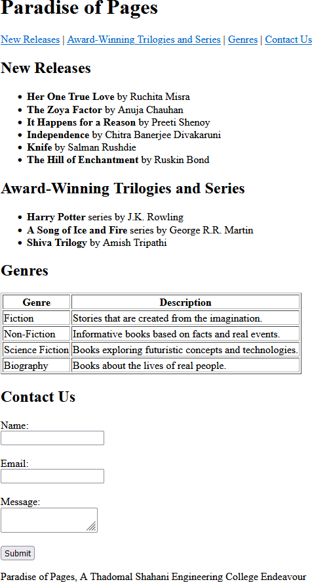OUTPUT:

CONCLUSION:

In conclusion, the HTML structure of the "Paradise of Pages" webpage effectively uses key elements to create a well-organized and user-friendly layout. The **<header>** and **<nav>** elements ensure easy navigation across sections, while the **<section>** element logically divides content into thematic areas. The **<ul>** and **<table>** elements help display lists and data in a readable format, enhancing the user experience